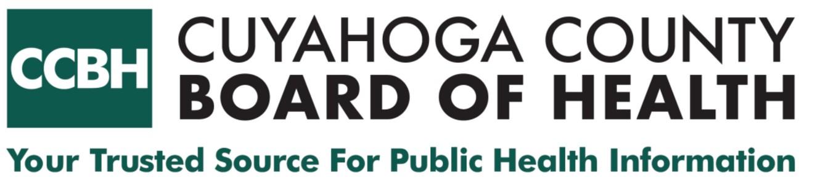
5550 Venture Drive | Parma, Ohio 44130
Direct: 216.201.2000 | Fax: 216.676.1311
ccbh.net

March 3, 2026

HBI (Healthy Brain Initiative) is an informal non-funded program at CCBH designed to protect the brain and foster better health from birth to the golden years. A number of factors can contribute to brain health including protecting your head, being smoke-free, regular exercise, challenging your mind, controlling blood pressure, managing diabetes, sleeping well, staying in school, eating right, and maintaining a healthy weight.

Our call to action is for listeners to empower themselves to keep their brain, as well as the rest of their body, healthy. Understanding the signs and symptoms of disease and consulting a physician when noticing changes would also be important for brain health.

Three Key Messages

Take charge of your brain health. Healthy habits can lower your risk of cognitive decline like dementia. Wear a helmet to protect your head when biking or climbing.

Staying fit with healthy eating and regular exercise helps more than just your body, it fuels your brain. This helps protect you from cognitive decline, like dementia.

High blood pressure and diabetes are thought to contribute to cognitive decline, like dementia. Controlling those symptoms and illnesses can help your brain develop healthfully throughout your life.

Closing after the message:
This message brought to you by the Cuyahoga County Board of Health, your trusted source for public health information.

