Oral Rabies Vaccination Program – ONRAB Field Trials
Ohio Talking Points

- In August 2016, Wildlife Services and cooperators will conduct U.S. field trials in 5 states with the ONRAB (Artemis Technologies, Guelph, Ontario, Canada) vaccine that is being used in Canada to control rabies in raccoons and skunks. The first U.S. field trial with ONRAB took place in West Virginia during 2011 and was expanded in 2012 to include strategic areas in Ohio, New York, Vermont, and New Hampshire. The 2016 studies will repeat and expand upon the work conducted in 2012-2014. The ONRAB field trial results for 2011-2016 will serve as part of the basis for potential licensure for use in the U.S. by the USDA-APHIS Center for Veterinary Biologics.

- ONRAB has proven to be effective in ORV campaigns to eliminate raccoon rabies in Canada. Results from the 2011 field trial in WV were encouraging, with vaccination rates approaching 50% in raccoons. Based on these results this vaccine-bait holds promise for WS and warrants further field study to determine if it could be applied in aggressive rabies control strategies toward the elimination of raccoon rabies.

- Beginning on or about August 22nd, approximately 252,000 baits containing the ONRAB oral rabies vaccine will be distributed in portions of northeast Ohio by fixed and rotary wing aircraft in rural areas and by vehicle in urban areas (Figure 1). The baits contain a rabies vaccine that if consumed by a raccoon should vaccinate the animal against the rabies virus. ONRAB does not contain rabies virus, but a gene from the rabies virus that causes raccoons and skunks that consume baits to come into contact with the vaccine, which results in an immune response through the production of antibodies that protect against rabies.

- This field trial will take place within a study area approximately 4,405 km² in size and will span portions of Ashtabula, Geauga, Lake, Portage and Trumbull counties. In urban areas, WS and state cooperator teams will distribute baits by ground means.

- The bait consists of a polyvinyl chloride (PVC) blister pack that contains the ONRAB rabies vaccine. To make the bait attractive, the blister packs are coated with a sweet attractant that includes vegetable-based fats, wax, icing sugar, vegetable oil, artificial marshmallow flavor, and dark-green food-grade dye (Figure 2).

- ONRAB may cause a cold-like infection in people who come into contact with the liquid vaccine through eyes, nose, and mouth (i.e., mucous membranes) or broken skin. Symptoms that may develop include a fever, sore throat, and headache (typical cold-like symptoms). Please wash the affected area thoroughly with soap and water and call the telephone number listed on the bait for further instructions and potential referral. Anyone who comes into contact with the liquid vaccine through mucous membranes or broken skin and is pregnant, has an immunodeficiency disease, or is on steroids is also recommended to contact a physician as a precaution. Most adults have been exposed to adenovirus during childhood, as adenoviruses are common and often cause asymptomatic respiratory infections.

- This vaccine has been shown to be safe in many species of animals, including domestic dogs and cats. Eating a large number of baits may cause a temporarily upset stomach in your pet but does not pose a long-term health risk. Do not attempt to remove a bait from your pet's mouth; doing so may cause you to be bitten and result in a vaccine exposure. It is also recommended to contact a veterinarian as a precaution if a pet has consumed vaccine baits.

- Between 2006 and 2011, more than 3.6 million ONRAB baits were distributed in Ontario, Canada and no reports of adverse events with humans were reported from 64 total contact calls that occurred during that time. Approximately 3 million ONRAB baits were distributed in Quebec, Canada between 2007-2010, with 16 total contact calls and no adverse events reported.

- The goal of the USDA Wildlife Services’ National Rabies Management Program is to prevent the spread of rabies in terrestrial wild carnivores such as raccoons, foxes and coyotes in the U.S. by containing and eliminating the virus. The program works cooperatively with the Centers for Disease Control and Prevention, and multiple federal, state, and local agencies and organizations.

- Wildlife Services is part of the USDA Animal and Plant Health Inspection Service. Its mission is to provide Federal leadership and expertise to resolve wildlife conflicts to allow people and wildlife to coexist.

- Oral rabies vaccination has been conducted in Ohio since 1997, using edible blocks or sachets containing the vaccine RABORAL V-RG® (Merial Ltd., Athens, Georgia).

- The public can help Wildlife Services and rabies control efforts by reporting strange acting animals to local animal control offices or Wildlife Services toll-free at 1-866-4-USDA-WS.

- If you find a bait, leave it undisturbed where you found it unless it is on your lawn, driveway, or other area unlikely to attract raccoons and other wildlife. Wear gloves if you move the bait to an area of thicker cover where raccoons are more likely to find it.

- Wash your hands thoroughly with soap and water after contact with baits. An intact bait poses no risk. If the blister packet containing the vaccine breaks the liquid vaccine should be visible. Use gloves to place the bait in a plastic bag. Cover the bait with 1:10 dilution of household bleach, and wipe down affected areas with bleach solution. Place cleaning materials in a bag, and dispose of the bag in regular garbage.

- Vaccination of domestic pets and livestock remains critical to prevent rabies.

NOTE:
For additional information or questions regarding these talking points, responders can contact USDA WS at 1-866-4-USDAWS.
Figure 1. Baiting plan for an ONRAB field trial targeting raccoons at 75 and 150 baits/km² in Ohio, 2016.

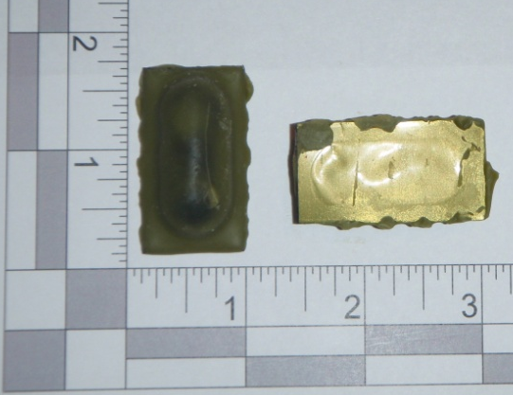
Figure 2. ONRAB “Ultralite” bait.

