CCBH Wordpress Training manual

CCBH Wordpress Training manual

Section | Page
1. How to Access Wordpress
2. How to Upload a File
3. How to Edit an Existing Page
a. Posts Page
b. Regular Page
4. How to Create a New Page
5. How to Update the “Forms” Section
a. Resident Homepage
b. Business Owner Homepage
c. Healthcare Provider Homepage
d. Job Searcher Homepage
6. How to Update the “Hot Topics” Section
a. Resident Homepage
b. Business Owner Homepage
c. Healthcare Provider Homepage
d. Job Searcher Homepage
7. How to Update the “Programs” Section
a. Resident Homepage
b. Business Owner Homepage
c. Healthcare Provider Homepage
d. Job Searcher Homepage

1. How to Access Wordpress

To make any changes on the website, you will need to access the Wordpress “backend”.
1. Go to the page www.ccbh.net/wp-admin
2. Enter your Username and Password.
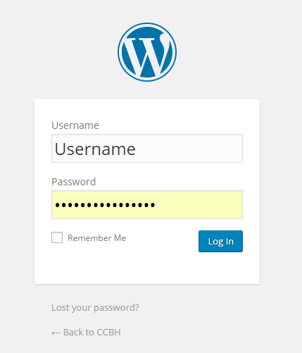

3. If your login is successful, you are now signed in to Wordpress. You are now viewing the “backend” of the website and can make changes.
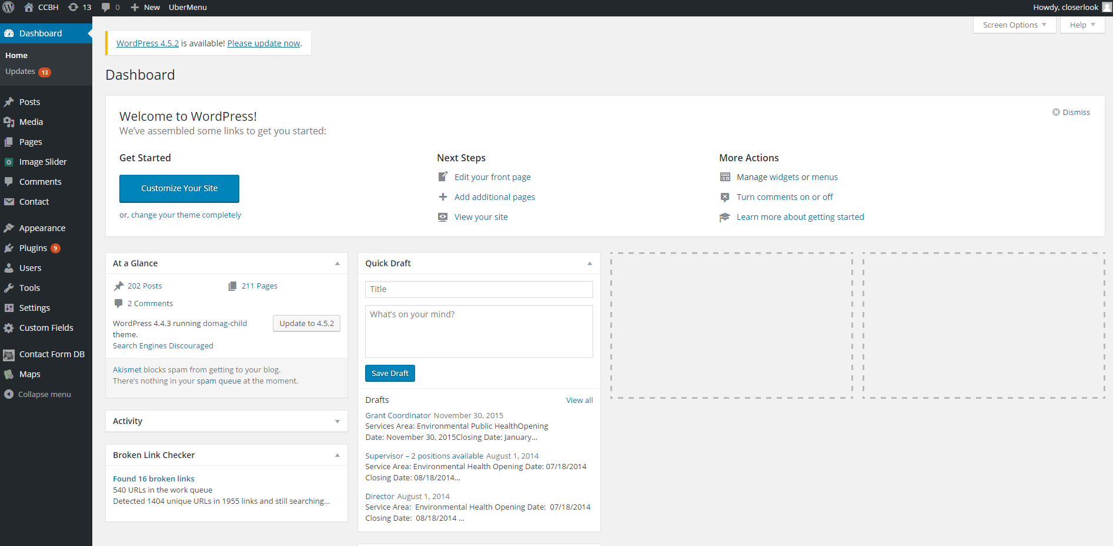

2. How to Upload a File

To upload an image, PDF or other file to the site, follow the steps below. Once the file is uploaded, you can then link to the file or add it to a page.
1. While in the Wordpress backend, hover over the tab for “Media” and click “Add New” 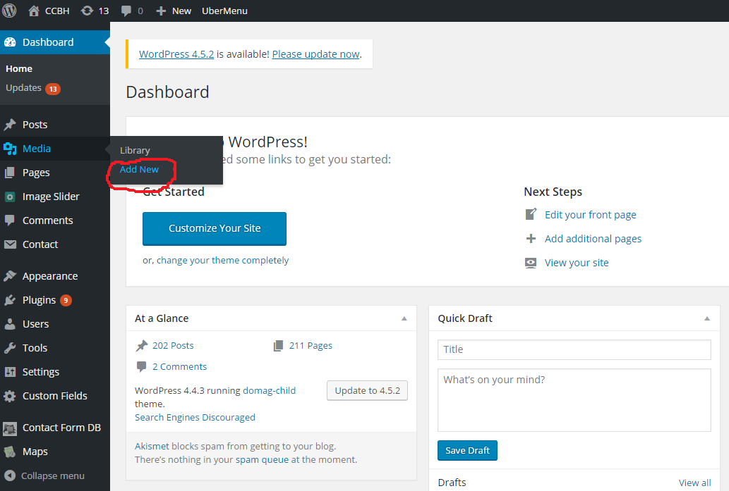
2. Press “Select Files” and then choose the file you wish to upload. 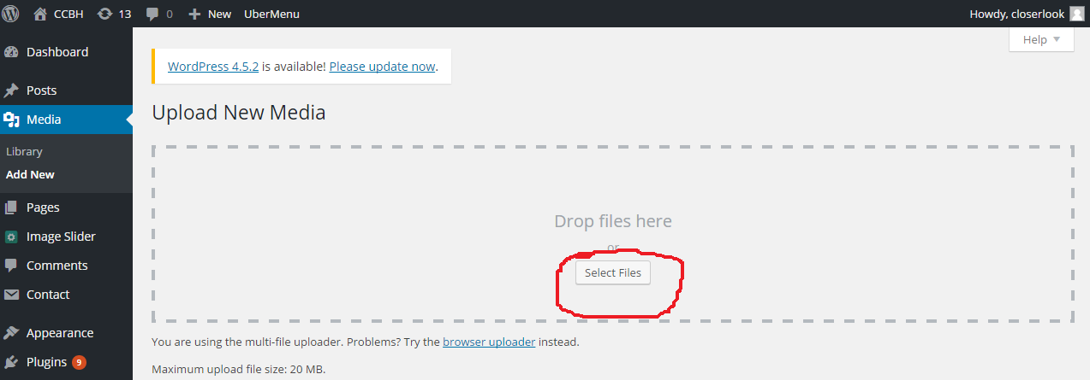
3.

